Chapter 15, Solution 4.

Design a problem to help other students better understand how to find the Laplace transform of different time varying functions.

Although there are many ways to solve this problem, this is an example based on the same kind of problem asked in the third edition.

Problem

Find the Laplace transforms of the following:

- g(t) = 6cos(4t – 1)
- f(t) = 2tu(t) + 5e^{-3(t – 2)}u(t – 2)

Solution
(a) 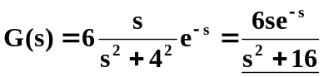

(b) 